# WeLib

## What is WeLib?

**# Source**: **Windows ScreenShots From Site -> https://welib.org/ at [9/21/2025]**

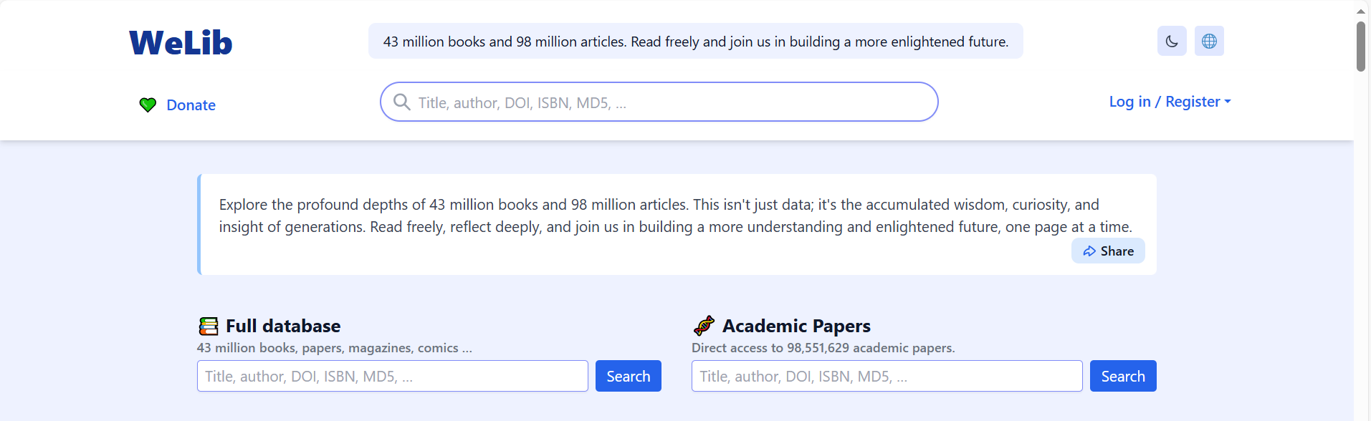

**# Source**: **Chatgpt (GPT-5-Standard) at [9/21/2025]**

* **WeLib.org** claims to provide access to **millions of books and academic papers** (e.g., 43 million books, 98 million papers).
* Some users online describe it as a kind of **alternative to sites like PDFDrive or Anna’s Archive**, hosting or mirroring large digital libraries.

## Risks and Red Flags

**# Source**: **Chatgpt (GPT-5-Standard) at [9/21/2025]**

* **ScamAdviser** flagged the site as suspicious:
  + The domain owner is hidden (WHOIS privacy).
  + The website is relatively new, with no long-term track record.
  + Reports exist of **spammy or unsafe behavior**.
* On **Reddit and forums**, users warn that it may be **malicious, unsafe, or misleading**, and could host pirated content.

## Bottom Line

**# Source**: **Chatgpt (GPT-5-Standard) at [9/21/2025]**

WeLib might look like a huge free library, but:

* Content may be **pirated and illegal**.
* There are **security risks** (malware, unsafe downloads, phishing).
* Using it could expose you to **legal or privacy issues**.